**A.1 Aim:**

Design Test cases for white box testing (Independent path)

## **Coding**

Inta,found=0;(1)

Char b_name[30],subject[30],author[30];

Void Search( ) (2)

{

cout<<”\n (1) SEARCH BY BOOK NAME :”;

cout<<”\n (2) SEARCH BY SUBJECT & AUTHOR :”; (3)

cin>>a;

if(a==1) (4)

{

gets(b_name); (5)

while(!ifile.eof() && found==0) (6)

{

ifile.read((char*)&S1,sizeof(detail)); (7)

if(strcmp(b_name,S1.book_name)==0) (8)

found=1; (9)

}

}

else (10)

{

gets(subject); (11)

gets(author);

while(!ifile.eof()) (12)

{

ifile.read((char*)&S1,sizeof(detail)); (13)

if(strcmp(subject,S1.subject)==0&&strcmp(author,S1. author)==0) (14)

print(s1); (15)

}

}

} (16)

## **Testing**

###### **7.1Flowgraph**

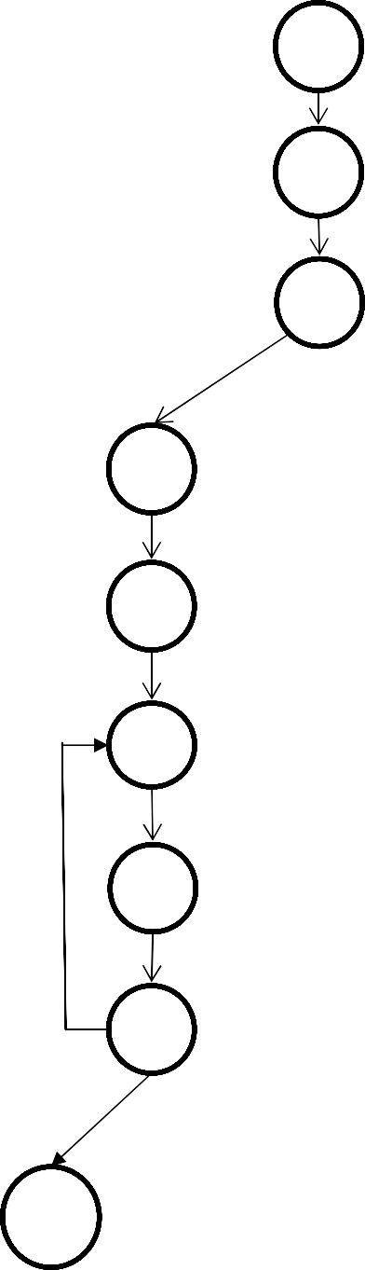

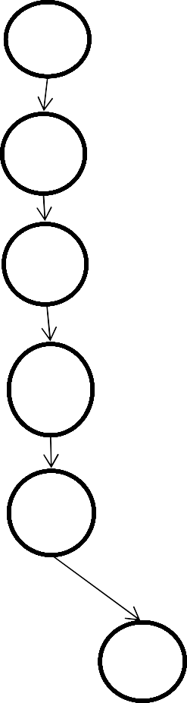

Paths:

Path 1: 1 2 3 4 5 6 16

Path 2: 1 2 3 4 5 6 7 8 6….

Path 3: 1 2 3 4 5 6 7 8 9 6…

Path 4 : 1 2 3 10 11 12 16

Path 5: 1 2 3 10 11 12 13 14 12…

Path 6: 1 2 3 10 11 12 13 14 15 12…

###### **Cyclomatic Complexity**

Using Regions: -

Number of regions = 6

Therefore, cyclomatic complexity = 6 Using Edges & Nodes: -

Number of Edges (E) = 20 Number of Nodes (N) =16 V (G) = E – N + 2

=20 – 16 + 2

=6

Therefore, cyclomatic complexity = 6 Using Predicate Nodes: -

No. Of predicate Nodes (P) =5 V (G) = P+1

=5+1

=6

Therefore, cyclomatic complexity = 6

* 1. ***Test cases***

**Test Case 1: P1:**

When the user enters, ‘Y’(to the Ques. that whether he knows the book name). Then the User enters the book name. ,

Program enters in While loop but the file does not exist or is empty.

& it exits

**Test Case 2: P3:**

When the user enters , ‘Y’(to the Ques. that whether he knows the book name.). Then the User enters the book name.

Then the program enters in While loop, searches the whole file & the corresponding book name is found.

& it exits

**Test Case 3:P2:**

When the user enters, ‘Y’(to the Ques. that whether he knows the book name). Then the User enters the book name.

Then the program enters in While loop, searches the whole file but the corresponding book name is not found.

& it exits

**Test Case 4:P4:**

When the user enters ‘N’(to Ques. that whether he knows the book name.) Then the user enters the subject and course name.

Program enters in While loop but the file does not exist or is empty.

& it exits.

**Test Case 5:P5:**

When the user enters ‘N’ (to the Ques. that whether he knows the book name)

Then the user enters the subject and course name.

Then the program enters in While loop, searches the whole file but the corresponding set of subject and course name is not found.

& it exits.

**Test case 6: P6:**

When the user enters ‘N’(to the Ques. that whether he knows the book name) Then the user enters the subject and course name.

Then the program enters in While loop , searches the whole file & the corresponding sets of subject and course name is found.

& it exits.

***\*\*Advantages and disadvantages of white box testing.***

Advantages / Pros of White Box Testing

**· Code optimization by revealing hidden errors**

**· Transparency of the internal coding structure which is helpful in deriving the type of input data needed to test an application effectively**

**· Covers all possible paths of a code thereby, empowering a software engineering team to conduct thorough application testing**

**· Enables programmer to introspect because developers can carefully describe any new implementation**

**· Test cases can be easily automated**

**· Gives engineering-based rules to stop testing an application.**

Disadvantages / Cons of White Box Testing

**· A complex and expensive procedure which requires the adroitness of a seasoned professional, expertise in programming and understanding of internal structure of a code**

**· Updated test script required when the implementation is changing too often**

**· Exhaustive testing becomes even more complex using the white box testing method if the application is of large size**

**· Some conditions might be untested as it is not realistic to test every single one**

**· Necessity to create full range of inputs to test each path and condition make the white box testing method time-consuming**

**· Defects in the code may not be detected or may be introduced considering the ground rule of analysing each line by line or path by path.**

**A.1 Aim:**

Using any SCM tool perform change specification and make different version

**PROCEDURE:**

**• Create new repository**

**• Upload the file that need to be changed**

**• Commit the operation**

**• Edit the uploaded file as per the user requirement**

**• Commit the changes**

**• View on History the two versioned file with different hashtag values**

**• Click on the hashtag of updated file and view the changes happened on which code**

**A.1 Aim:**

To prepare the RMMM Plan.

**Risk Management**

**Risk components:**

(1) *Performance risk—*the degree of uncertainty that the product will meet its requirements and be fit for its intended use.

(2) *Cost risk—*the degree of uncertainty that the project budget will be maintained.

(3) *Support risk—*the degree of uncertainty that the resultant software will be easy to correct, adapt and enhance.

(4) *Schedule risk—*the degree of uncertainty that the project schedule will be maintained and that the product will be delivered on time.

· Impact of each risk driver on the risk component is divided into one of four impact categories—negligible, marginal, critical, or catastrophic

##### Figure 1 - Risk Characterization Table



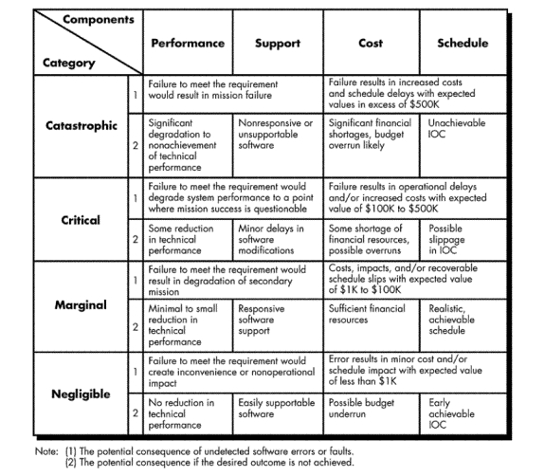

**RISK TABLE FOR SENTIMENT ANALYSIS OF DIGITAL BOOKSTORE**

|  |  |  |  |
| --- | --- | --- | --- |
| Risks | Category | Probability | Impact |
| Quality is not maintained | PS | 60% | 2 |
| Customer will change requirements | PS | 80% | 3 |
| Staff inexperienced | ST | 30% | 3 |
| Delivery deadline will be tightened | BU | 50% | 2 |
| Lack of cooperation from users | CU | 30% | 1 |
| Lack of effective project managing technology | BU | 40% | 1 |
| Inadequate estimation of required resources | PS | 50% | 1 |
| Loss of database | PS | 50% | 1 |
| Developing a wrong user interface | DE | 70% | 2 |

PS – Product Size IMPACT VALUES

BU- Business Impact 1.CATASTROPHIC

CU- Customer Characteristics 2.CRITICAL

DE- Development environment 3.MARGINAL

ST- Staff Size 4.NEGLIGIBLE

|  |  |  |  |
| --- | --- | --- | --- |
| **RISK INFORMATION SHEET** | | | |
| RISK ID: DA-AS232 | DATE:10/04/15 | PROB: 50% | IMPACT: CATASTROPHIC |
| DESCRIPTION:  Due to various technical reasons or natural calamities, the Database of the system may be lost or damaged. | | | |

|  |
| --- |
| Refinement:  Subcondition1: Certain checkpoints are recorded in the system periodically  Sub Condition 2:As a part of check-pointing, after every update in the database, checkpoints are updated which states that the database is updated correctly till that point. |
| Mitigation/Monitoring:   1. A copy of all the databases must be maintained side by side on a different system. Also, it must be updated simultaneously. 2. A recovery tool must be designed which could recover the database according to the checkpoints. |
| Management  A special team is allocated for the recovery of the database as soon as possible. The secondary databases which were maintained as a copy must be made primary so that the working of the software is not affected. |

**Case Study:**

Scope and intent of RMMM activities

The goal of the risk mitigation, monitoring and management plan is to identify as many potential risks as possible.

The project will then be analyzed to determine any project-specific risks.

When all risks have been identified, they will then be evaluated to determine their probability of occurrence, and how Digital Bookstore will be affected if they do occur. Plans will then be made to avoid each risk, to track each risk to determine if it is more or less likely to occur, and to plan for those risks should they occur.

It is the organization’s responsibility to perform risk mitigation, monitoring, and management in order to produce a quality product. The quicker the risks can be identified and avoided, the smaller the chances of having to face that particular risk’s consequence. The fewer consequences suffered as a result of a good RMMM plan, the better the product, and the smoother the development process.

**Risk management organizational role**

Each member of the organization will undertake risk management. The development team will consistently be monitoring their progress and project status to identify present and future risks as quickly and accurately as possible. With this said, the members who are not directly involved with the implementation of the product will also need to keep their eyes open for any possible risks that the development team did not spot. The responsibility of risk management falls on each member of the organization.

**Class Diagram:**

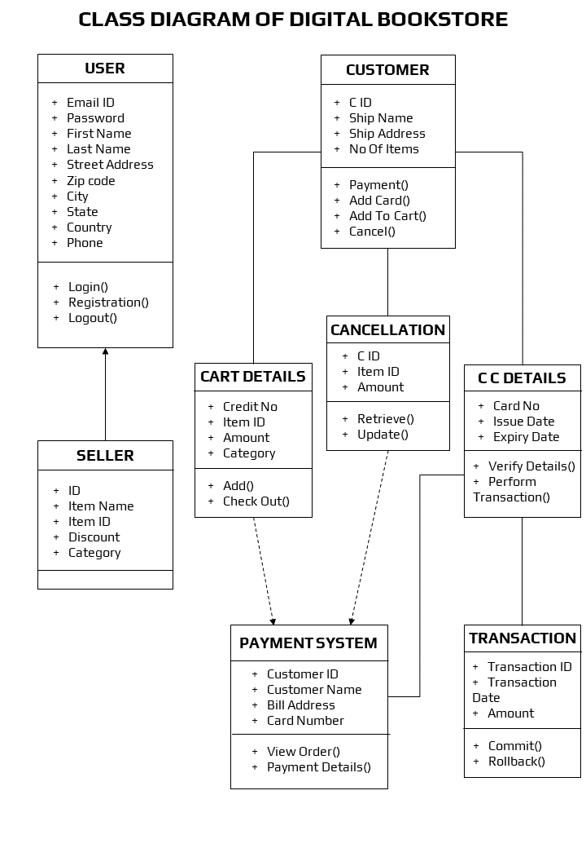

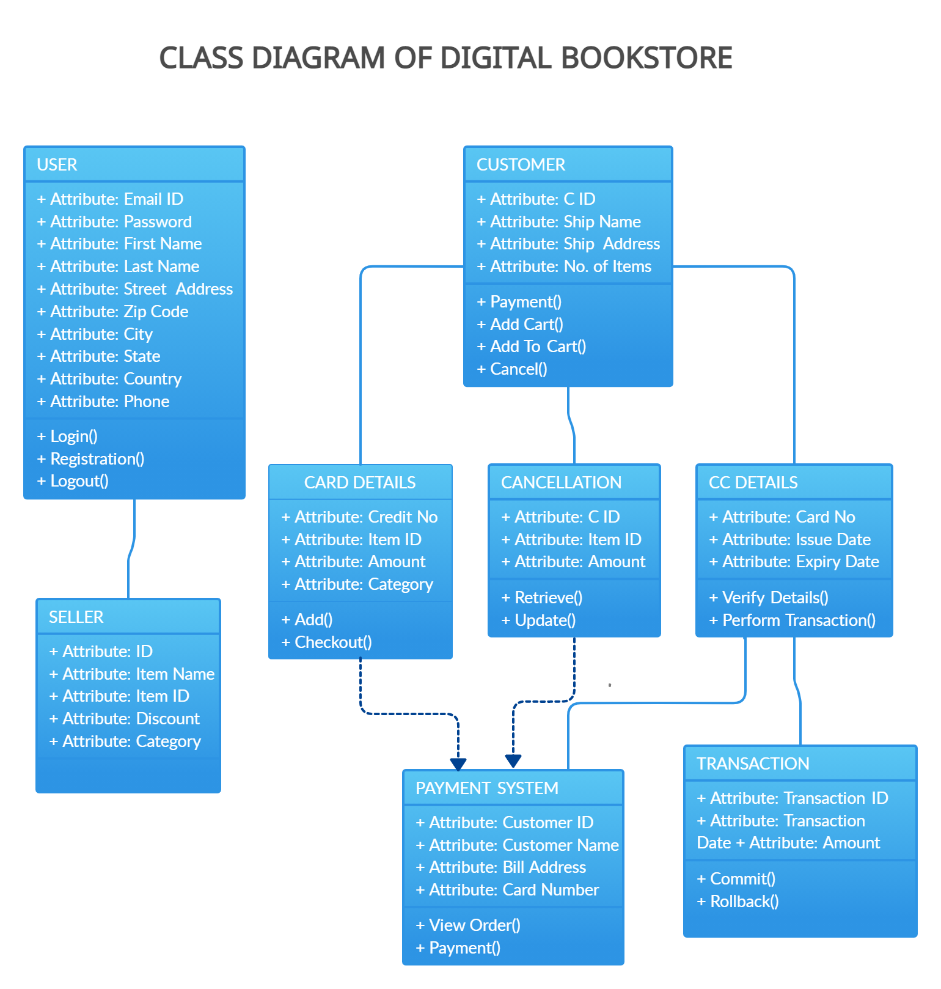

## **Sequence Diagram:**

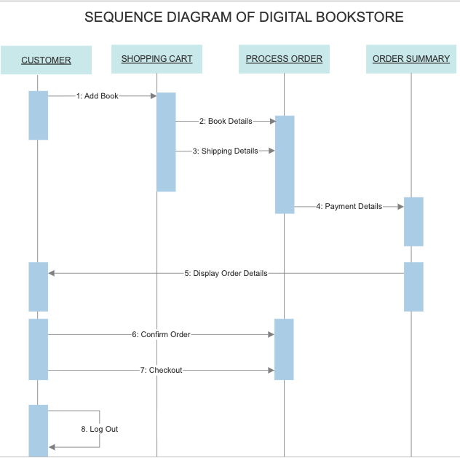

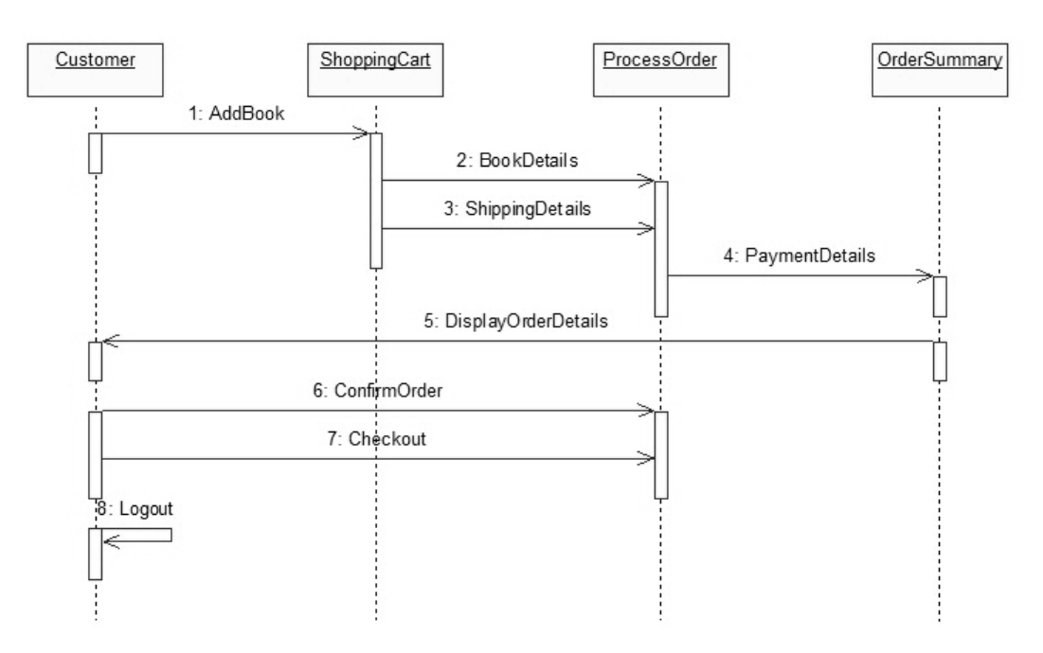

**Collaboration Diagram:**

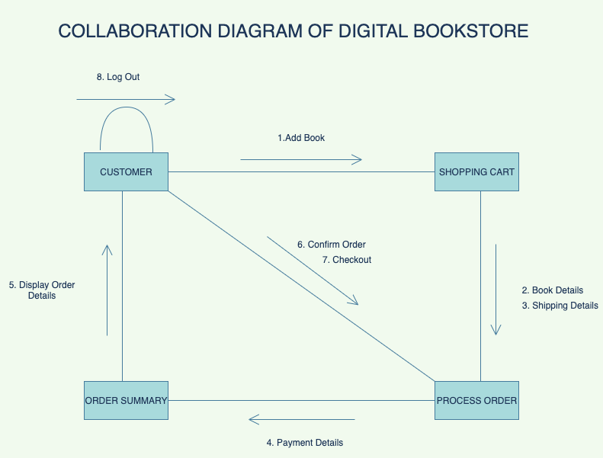

**Statechart Diagram:**

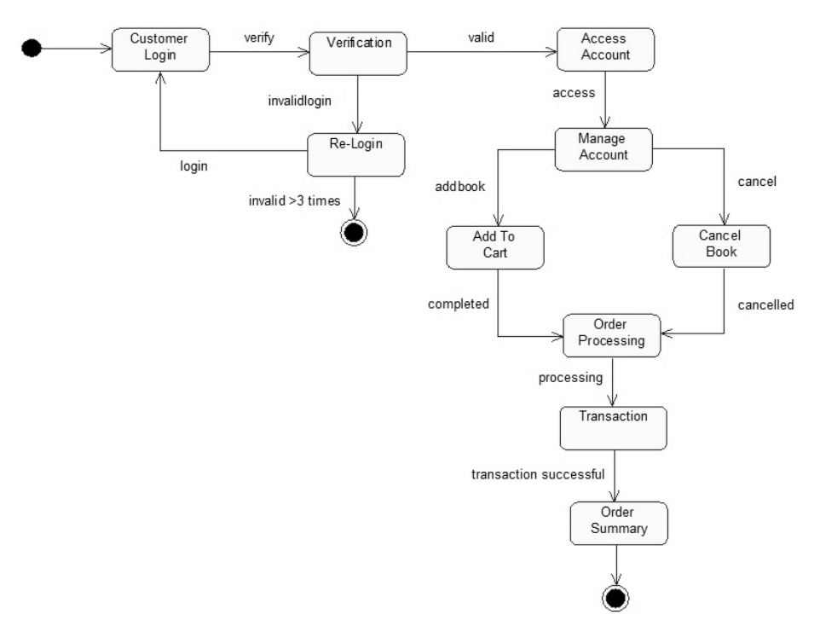

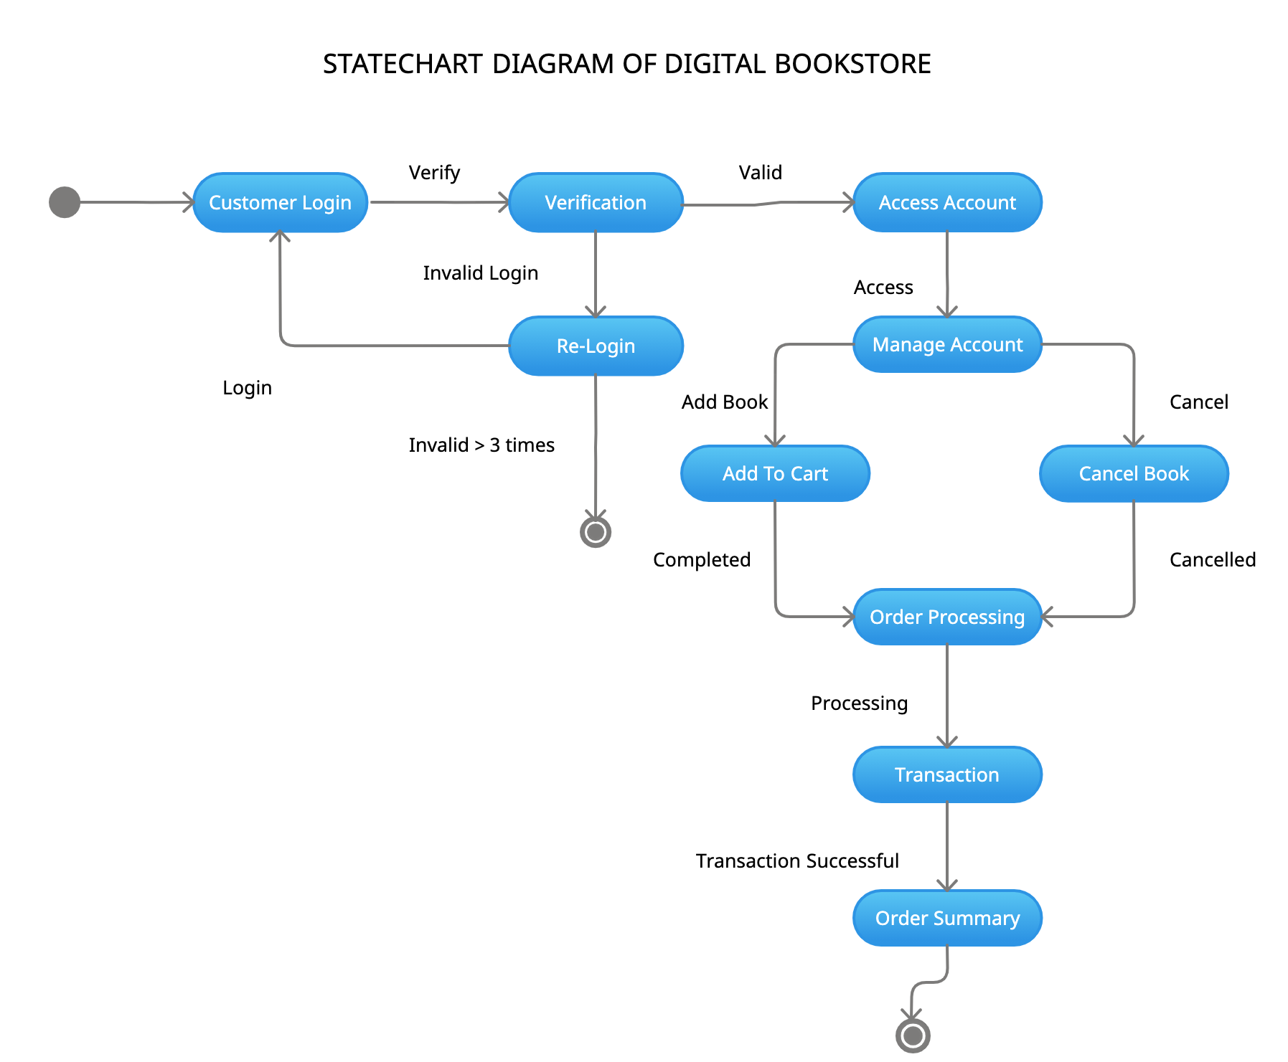

**Activity Diagram:**

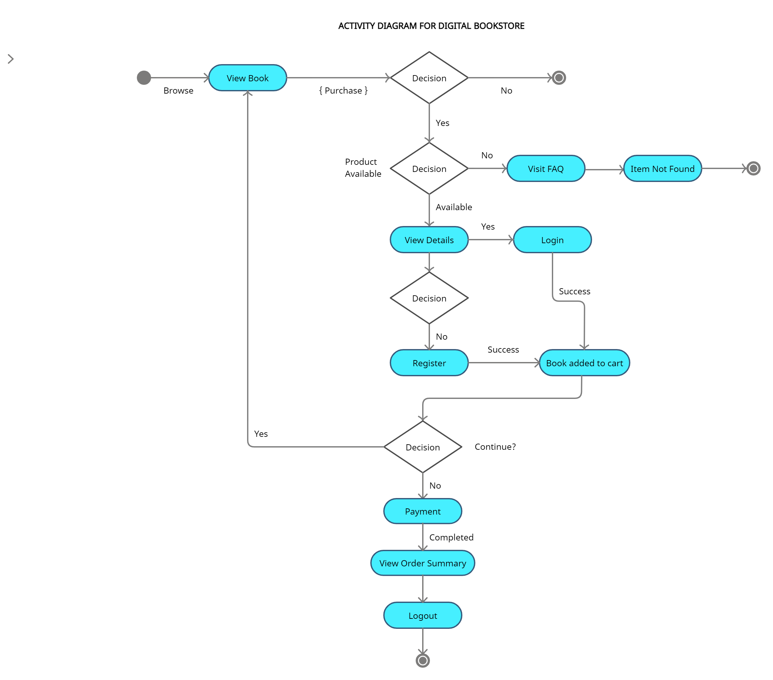

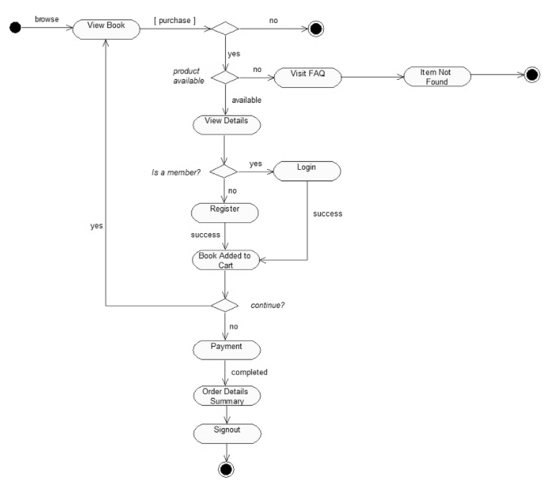

**Component Diagrams:**

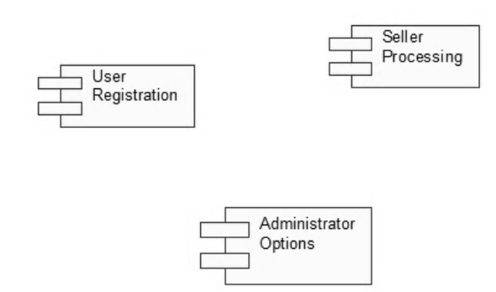

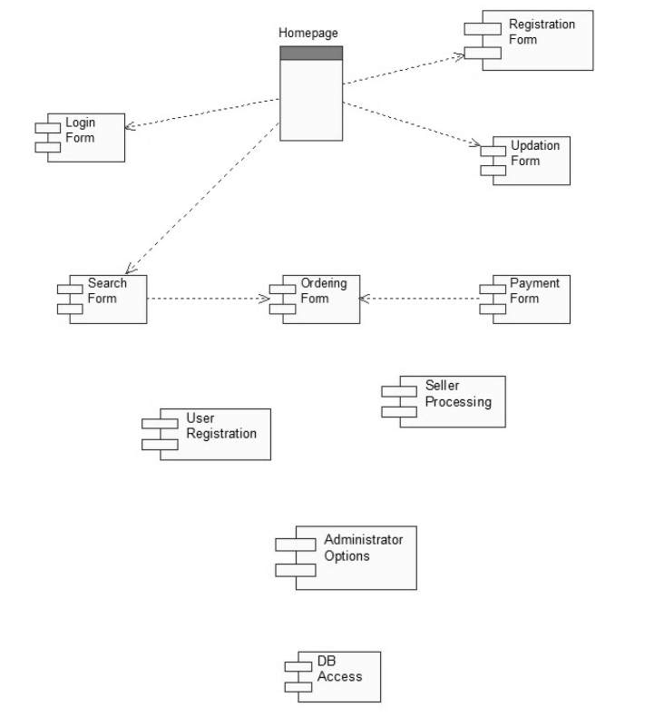

**Deployment Diagram:**

